**Module 7: JQuery Basic, Effects & Advanced**

**1.What is jQuery?**

**A:** jQuery is a fast, small, and feature-rich JavaScript library. It makes things like HTML document traversal and manipulation, event handling, animation, and Ajax much simpler with an easy-to-use API that works across a multitude of browsers. With a combination of versatility and extensibility, jQuery has changed the way that millions of people write JavaScript.

**2. How to Apply CSS Using JQuery, How to Add Class and Remove Class in Jquery, JQuery Animation?**

**A:**

**CSS Using JQuery:**

<!DOCTYPE html>

<html lang="en">

<head>

    <meta charset="UTF-8">

    <meta name="viewport" content="width=device-width, initial-scale=1.0">

    <title>Document</title>

    <script src="https://cdnjs.cloudflare.com/ajax/libs/jquery/3.7.0/jquery.min.js"></script>

</head>

<body>

    <div>hiii</div>

    <button>xyz</button>

    <script>

        $(document).ready(function () {

            $("button").click(function () {

                $("div").css({ "background-color": "aqua","font-size": "50px"})

            })

        })

    </script>

</body>

</html>

**Output:**

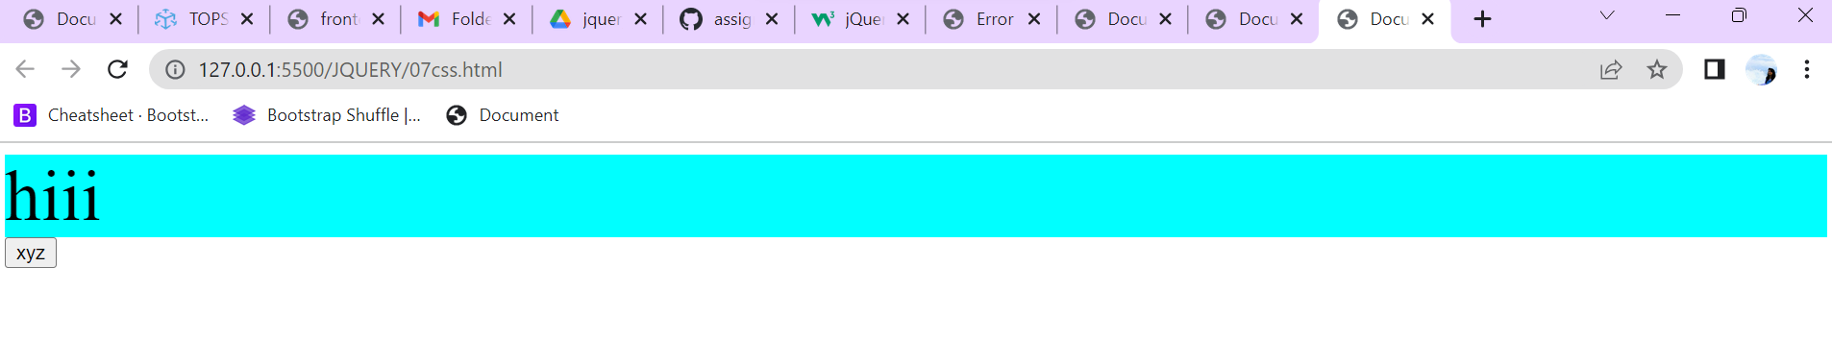

**Add Class:**

<!DOCTYPE html>

<html lang="en">

<head>

    <meta charset="UTF-8">

    <meta name="viewport" content="width=device-width, initial-scale=1.0">

    <title>Document</title>

    <script src="https://cdnjs.cloudflare.com/ajax/libs/jquery/3.7.0/jquery.min.js"></script>

    <style>

        div{

            height: 100px;

            width: 100px;

            background-color: aqua;

        }

        .one{

            font-size: 50px;

            background-color: chartreuse;

        }

    </style>

</head>

<body>

    <div>jinal</div>

    <button>xyz</button>

    <script>

        $(document).ready(function () {

            $("button").click(function () {

                $("div").addClass("one")

            })

        })

    </script>

</body>

</html>

**Output:**

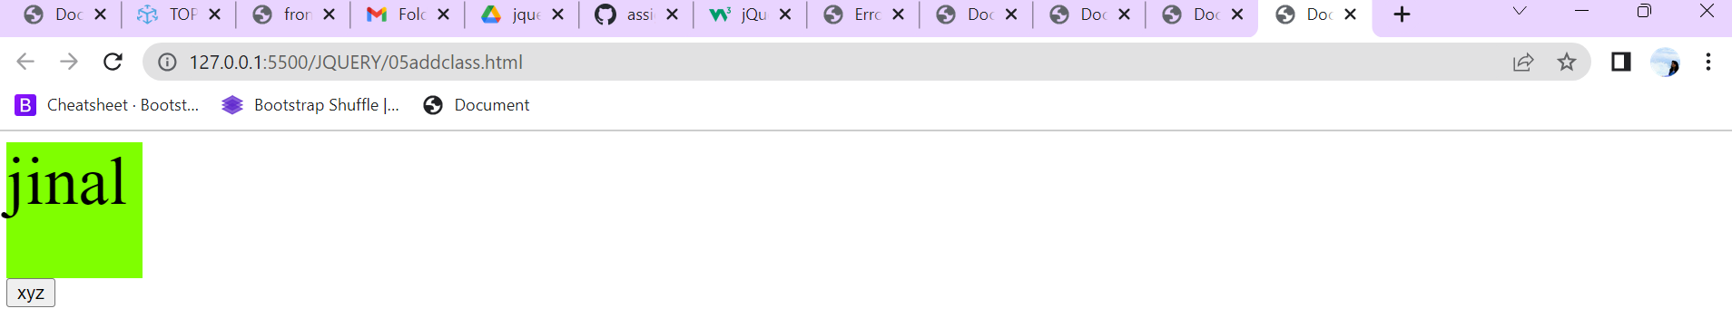

Remove Class:

<!DOCTYPE html>

<html lang="en">

<head>

    <meta charset="UTF-8">

    <meta name="viewport" content="width=device-width, initial-scale=1.0">

    <script src="https://cdnjs.cloudflare.com/ajax/libs/jquery/3.7.0/jquery.min.js"></script>

    <title>Document</title>

    <style>

        .one{

            height: 300px;

            width: 300px;

            background-color: aqua;

        }

    </style>

</head>

<body>

    <div class="one">Lorem ipsum dolor sit amet, consectetur adipisicing elit. Laboriosam autem illum quam ab et enim, quae maiores quos aliquam mollitia qui odio esse nostrum provident est debitis exercitationem praesentium. Ducimus?</div>

    <button>xyz</button>

    <script>

        $(document).ready(function () {

            $("button").click(function () {

                $("div").removeClass("one")

            })

        })

    </script>

</body>

</html>

**Output:**

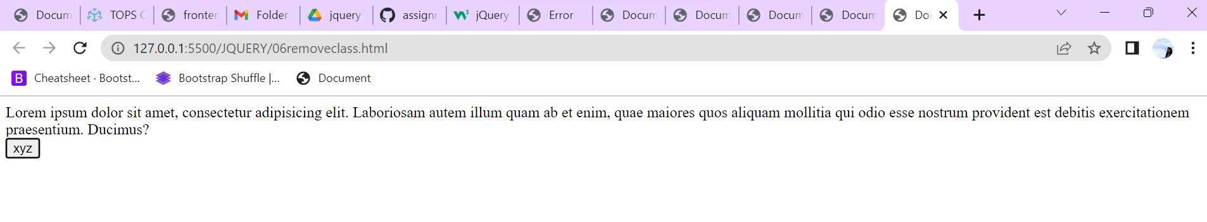

**JQuery Animation:**

<!DOCTYPE html>

<html lang="en">

<head>

    <meta charset="UTF-8">

    <meta name="viewport" content="width=device-width, initial-scale=1.0">

    <title>Document</title>

    <script src="https://cdnjs.cloudflare.com/ajax/libs/jquery/3.7.0/jquery.min.js"></script>

    <style>

        div {

            height: 100px;

            width: 100px;

            background-color: aqua;

            position: relative;

        }

    </style>

</head>

<body>

    <div></div>

    <button>xyz</button>

    <script>

        $(document).ready(function () {

            $("button").click(function () {

                $("div").animate({ "left": "250px" }).css({ "background-color": "red" })

            })

        })

    </script>

</body>

</html>

**Output:**

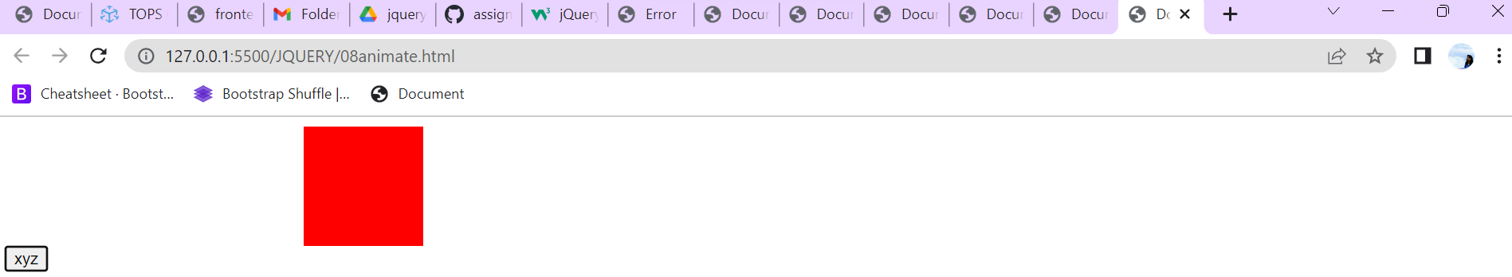

**3. How to create slider with animation?**

* JQuery animate () method
* The method used to create custom animations called the JQuery animate () method. This type of method used to animate CSS properties , like, width, height, margin, opacity, top, left and padding.

**Example:**

<!DOCTYPE html>

<html lang="en">

<head>

    <meta charset="UTF-8">

    <meta name="viewport" content="width=device-width, initial-scale=1.0">

    <title>Document</title>

    <script src="https://cdnjs.cloudflare.com/ajax/libs/jquery/3.7.0/jquery.min.js"></script>

    <style>

        div {

            height: 200px;

            width: 200px;

            background-color: aqua;

        }

    </style>

</head>

<body>

    <button>stop</button>

    <div class="one">Slide1</div>

    <div class="two">Slide2</div>

    <script>

        $(document).ready(function () {

            $(".one").click(function () {

                $(".two").slideToggle(3000)

            })

            // slideup

            // sliddown

            $("button").click(function () {

                $(".two").stop()

            })

        })

    </script>

</body>

</html>

**Output:**

